**DAILY ONLINE ACTIVITIES SUMMARY**

|  |  |  |  |  |  |  |  |
| --- | --- | --- | --- | --- | --- | --- | --- |
| **Date:** | **03-06-2020** | | | | **Name:** | **Varsha H Shetty** | |
| **Sem & Sec** | **8th sem B sec** | | | | **USN:** | **4AL16CS117** | |
| **Online Test Summary** | | | | | | | |
| **Subject** | | **-** | | | | | |
| **Max. Marks** | | **-** | | **Score** | | **-** | |
| **Certification Course Summary** | | | | | | | |
| **Course** | **AWS lambda foundations** | | | | | | |
| **Certificate Provider** | | | **AWS training & certificationwebsite** | **Duration** | | | **60 minutes** |
| **Coding Challenges** | | | | | | | |
| **Problem Statement-** : **Problem Statement:**  **1) To print the pattern of the following form containing the numbers**  **Sample Input 0**  **2**  **Sample Output 0**  **2 2 2**  **2 1 2**  **2 2 2** | | | | | | | |
| **Status: completed** | | | | | | | |
| **Uploaded the report in Github** | | | | **yes** | | | |
| **If yes Repository name** | | | | **Varsha-Shetty** | | | |
| **Uploaded the report in slack** | | | | **yes** | | | |

Certification Course Details: (Attach the snapshot and briefly write the report for the same)

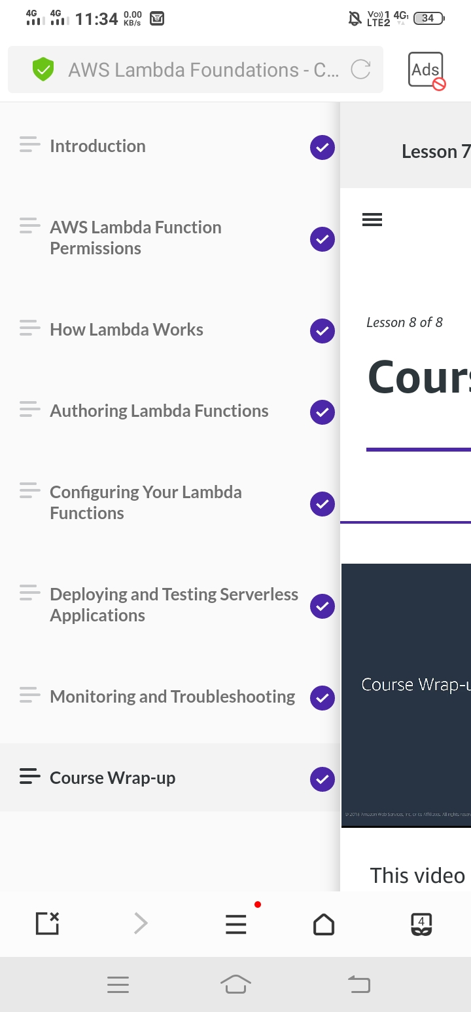

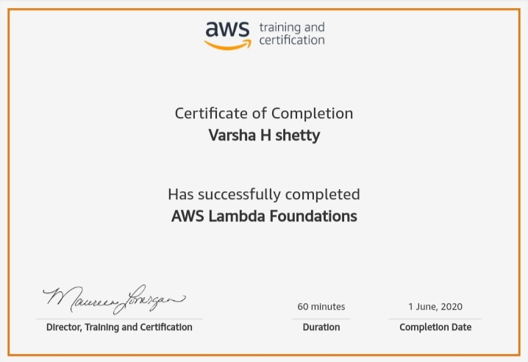

Coding Challenges Details: (Attach the snapshot and briefly write the report for the same)

Coding was given and it was uploaded for github and slack

**#include <stdio.h>**

**int main()**

**{**

**int n;**

**scanf("%d", &n);**

**int len = n*2 - 1;**

**for(int i=0;i<len;i++){**

**for(int j=0;j<len;j++){**

**int min = i < j ? i : j;**

**min = min < len-i ? min : len-i-1;**

**min = min < len-j-1 ? min : len-j-1;**

**printf("%d ", n-min);**

**}**

**printf("\n");**

**}**

**return 0;**

**}**

|  |
| --- |
|  |